

# Assignment 1 Keyword Research and Page Optimization

### Learning Outcomes

1. Basic understanding of search engine optimization
2. Familiarity with industry standard SEO tools
3. Basic keyword analysis
4. Page optimization and technical SEO techniques

### Submission Instructions

To get credit, students will download, complete and submit this completed document before the posted due date posted in Canvas.

# Keyword Research

Keyword research is an important first step in any SEO strategy. In order to get people to your site, you must first know which words they already using to find you. Oftentimes, the terms people are actually using may not be exactly what you expect. For example, let's imagine we own a small craft brewery. This brewery makes many different styles of beer but their light beers seem to be best sellers. The Brewery has a website that is optimized for the terms “light beer” or “lite beer”. We think these are good terms because they encompass a variety of products and are in line with popularity. But when we dig a little deeper, we realize that using these terms may be hurting our search results instead of helping!

When we search for “light beer” or “lite beer” we are presented with links to the websites of Miller, Coors and Budweiser. As much as I would like my small brewery to compete with these mega-brewers, it is just not realistic. In fact, my website does not show up on the first or second page when searching for these terms. How can this be? I thought my site was “optimized”?

Well, the truth of the matter is that my site is optimized, just not for the right terms. More specific terms like “blonde ale” or “new york pale ale” or “best pale ale in northeast” would be much better. First, when I test these terms the results seem to be much more in line with my actual business competitors. Also, someone who is searching for a very specific type of beer that I offer is typically a better qualified lead than someone simply looking for a generic light beer.

Now that we know the truth about how people find us, we need to rethink the content, markup and possibly the structure of our website to **optimize** it for these new search terms.

## Product of Service

For the purposes of this assignment, you will be analyzing the product or service you have chosen for the semester. Pay close attention to the terms they currently use to describe their product or service. Are there specific terms that seem to be used repeatedly? Can you start to guess what users might type into a search engine (Google) to find this product or service?

**Brainstorming**

Believe it or not, most keyword research starts with a series of guesses. Marketers and SEO professionals simply take educated guesses on what terms customers might use to find their product or service. This may seem a bit unscientific — and it is — but this stage of the research process is just about creating a starting point. We will refine this list later.

**Task #1**

Using the space below, create a list of words or phrases that a Google user might use to find your product or service. List at least **20 terms or phrases** to start. Don’t limit yourself at this point, put down any terms or phrases you think might be relevant. You may include [branded and non-branded terms](https://searchenginewatch.com/sew/how-to/2405547/brand-vs-non-brand-measurement-is-key).

1. Cleanser
2. Clean ingredients
3. Face Wash
4. Make up remover
5. Plant-based
6. Hydrate
7. Skincare
8. Silky
9. Luminous
10. Skin
11. Nourish
12. Vitamins
13. Strengthen
14. Brighten
15. Protect
16. Sensitive skin
17. Exfoliate
18. Organic
19. Natural
20. Clean
21. Vegan
22. Indie Lee

Now that we have our basic keyword list, let's add some variations. We do this by adding “stems” to our list of brainstormed terms. Stems are words like “How do I _______” or “Where can I ________” that are added to the beginning or ending of the original keyword or phrase. These stems can take a very generic term and make it much more specific. These stems added to the keyword list above create what is known as “long tail” keywords. [Google suggest feature](https://www.searchenginejournal.com/beginners-guide-google-suggest-marketers-seo/73269/) can help with this process.

**Task #2**

See if you **can come up with at least fifteen long-tail keywords** in the space below that will work to attract the right customers to your company's website.

1. How do I treat sensitive skin?
2. How do I brighten my skin?
3. What is a hydrating cleanser?
4. How do I nourish my skin?
5. How do I best remove makeup?
6. Where can I find a clean cleanser?
7. What is a vegan cleanser?
8. What are the best vegan cleansers?
9. How do I hydrate my face?
10. What is plant-based?
11. Where can I find organic skincare products?
12. How can I improve my skin?
13. What is the best organic skincare product?
14. How do I protect and brighten my skin?
15. Why is clean skincare important?
16. How do I make sure my cleanser is organic?

**Analysis**

Now we are going to analyze our keyword list to see how close we actually are to keywords that people are actually using for search. There are many tools out there that can help us research and plan keywords for any particular web page. [Google’s AdWords Keyword Planner](https://adwords.google.com/KeywordPlanner) and the [free version of WordTracker](https://freekeywords.wordtracker.com/sign_in/) are popular choices.

Suggested Keywords

To get started access the [Google AdWords Keyword Planner Tool](https://adwords.google.com/KeywordPlanner). In order to access the tool, you will need a Gmail account, and you will need to sign up for Google AdWords. AdWords is Google’s online advertising product for placing pay-per-click ads and display ads. We will use this tool again later in the semester. Once you have access to the Keyword Planning Tool, click the “Search for new keyword and ad group ideas” option.

**NOTE: You do not have to pay for this service.** [**Read this article to start using the keyword planner tool without entering any credit card information into Google Adwords**](https://ahrefs.com/blog/google-keyword-planner/)**.**  If you are having trouble gaining access to the keyword planner tool contact me for help.

To continue researching keyword ideas choose the “find new keywords” option.

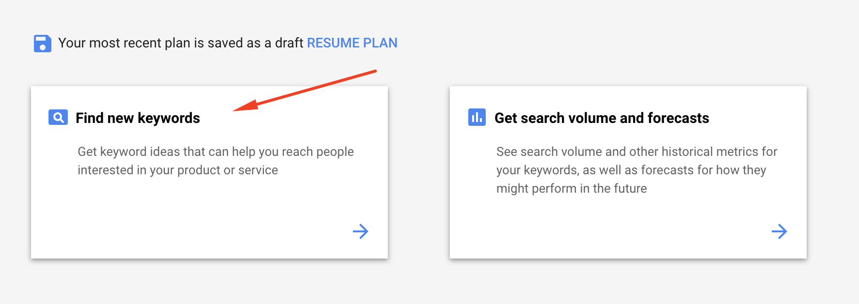

Enter a few “seed” keywords that describes your product or service and/or a url that describes it. Then click “get started”.

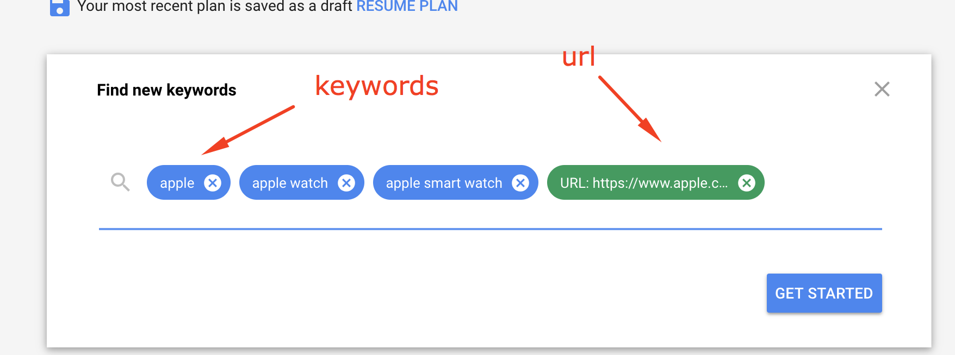

You should be presented with around 1000 - 1200 keyword ideas, a vague number of average monthly searches, an indication of how competitive this keyword is, and some suggested bids. This information should give you some indication of the quality of the keyword. If you would like to dig a little deeper, [this article goes into detail about how to get the most out of the keyword planner tool](https://ahrefs.com/blog/google-keyword-planner/).

Take a look at the suggestion the Keyword Planner tool has provided. Are they in line with your original brainstorm list? Are there any surprises? Go back and change your “seed” keywords and/or URL. See how it affects the suggested keyword list.

Click the checkbox next to keywords you think you may want to rank for and add them to your keyword plan. I would suggest you add about 15-20 keywords to your plan.

**Task #3**

Take screenshot of **your keyword plan** and paste in the space below.

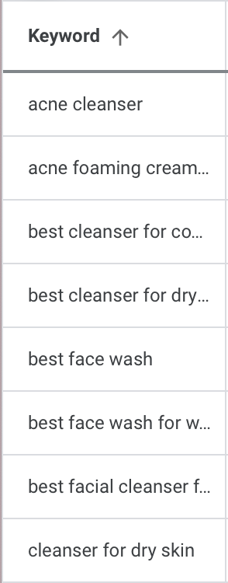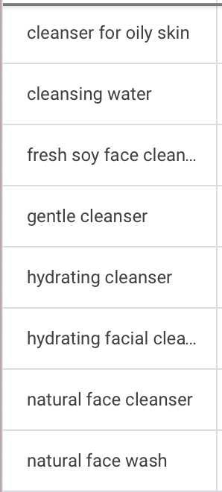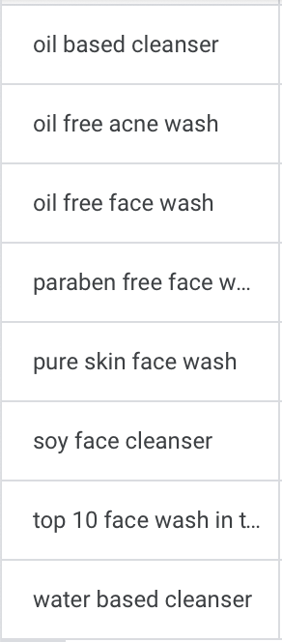

After looking at all the suggested keywords what have you learned? How will you make adjustments?

I learned that the suggested keywords appear as phrases rather than just terms. Some keywords that stood out to me that I hadn’t included in my initial brainstorming are gentle, cleansing water, acne cleanser, water-based cleanser, pure skin face wash, cleanser for oily skin, paraben-free, and soy face cleanser. Overall, I noticed that these keywords relate more to what the consumers are looking for to help their own skin rather than all the benefits of the exact product. My initial list was too vague and did not consist of long enough keywords.

**Relevance**

Knowing what terms users are searching is one thing, but making sure those terms accurately describe your product or service is another. Take a look at the suggested keywords from the previous steps. Do they accurately describe your product or service? Think to yourself, “When the user searches this query, what are they looking for? What do they want? If they find my site, will it meet their needs?” If your results are like mine, most suggested terms should be fairly relevant, however, there are usually a few terms that are way off base. That is ok, just take note of the terms you think are bad. We will use this to help refine our list later.

**Search Volume**

Our next step is to analyze search volume and competition for the suggested terms. After adding keywords to your plan, click the “Keywords” on the right hand navigation as indicated in the screenshot below. This view will give you additional keyword volume information like number of expected clicks and impressions.

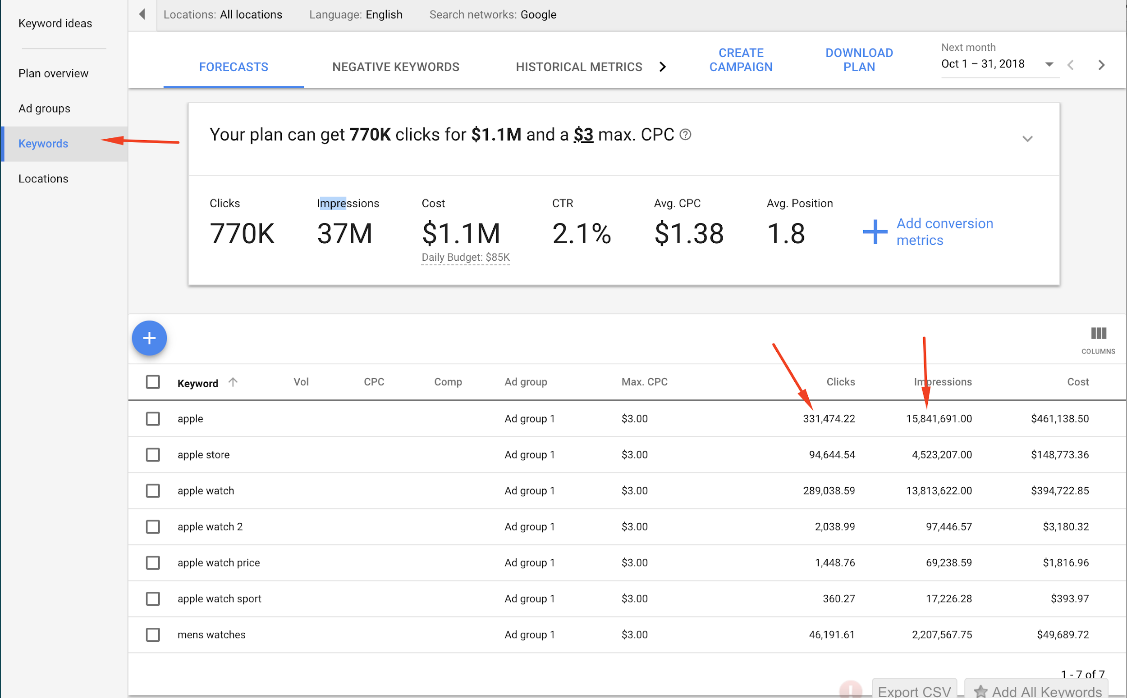  
  
We are going to use these metrics to refine our keyword list even further, but here is where things get a little tricky. We don’t necessary want to choose all the terms that have the highest average monthly searches, impressions and clicks. We may want to include more specific long tail terms that have a highly likelihood of getting people to your site. Also, we want to ensure these keywords are relevant to our product or service.

Take a look at the example below.   
   
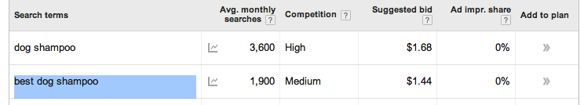  
The term “dog shampoo” has 3600 monthly searches but high competition. The search phrase “best dog shampoo” has 1900 average monthly searches but lower competition.

**Task #4**

In the space below, tell me **which term in the above example** do you think would be a more effective in terms of getting users to your site and why?

The term “best dog shampoo” would be more effective in terms of getting users to the site. This is because although the monthly average search is lower and the competition is medium it is more likely for users to find your product and go to that exact page. If users were to use the term “dog shampoo” they would most likely land on larger companies sites like Petco, Amazon, and chewy.com. Therefore, the term “best dog shampoo” would more likely get consumers to the dog shampoo site.

**Task # 5**

Do your best to narrow down your terms based on what we have learned so far. Get rid of terms that you think are not very relevant to your product or service and add good suggested terms from your keyword research. You may also want to remove terms that do not get enough search volume.

At this point you should try to get your list down to about **ten to fifteen high quality terms**.  **Paste those terms in the space below.** Remember, there is no right answer here, SEO is an iterative process of elimination.

1. Organic cleanser
2. Facial cleansing
3. Face wash for dry skin
4. Skin cleanser foam
5. Winter face wash
6. Best oil skin face wash
7. Winter best face wash
8. Cleanser for oily skin
9. Combination skin cleanser
10. Oil and acne preventing face wash
11. Natural skin cleanser
12. Body care face wash
13. Top cleansers for combination skin
14. Natural cleanser for daily use
15. Oily skin care face wash

Now it is time to get tough and take a good look at our competition. This phase of the keyword research process is about making sure we are competing in the right space, using the right terms. We want to make sure that the search results for any targeted terms are right for our product.

To start our competition analysis, select one of your targeted terms from your refined list. In the example below I chose to use “best dog shampoo” as my selected term. Type the term or phrase you selected into a normal Google search box and take a look at the results. Are these your competitors? If you think they are, take another look…are they really?  
  
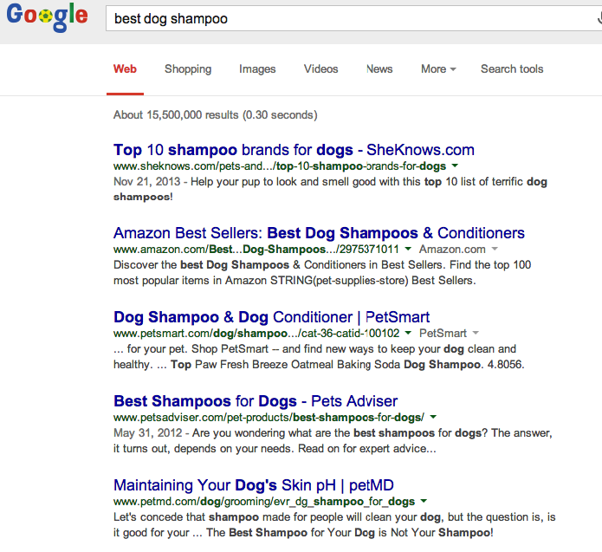

In the example above, you can see that this term yields results that are not exactly direct competitors. The results for this term are mostly how-to blog articles and large online retailer sites. For this particular website my direct competitors would be actual shampoo manufacturers, not retailers and bloggers.

Let's try another term. This time I typed “all natural dog shampoo” into Google. If you look at the results for this term you can see that most of the results are actual shampoo manufacturers, not retailers. These results also seem to similar to my product in terms of the size of the company as well. This is good! We are getting closer!  
  
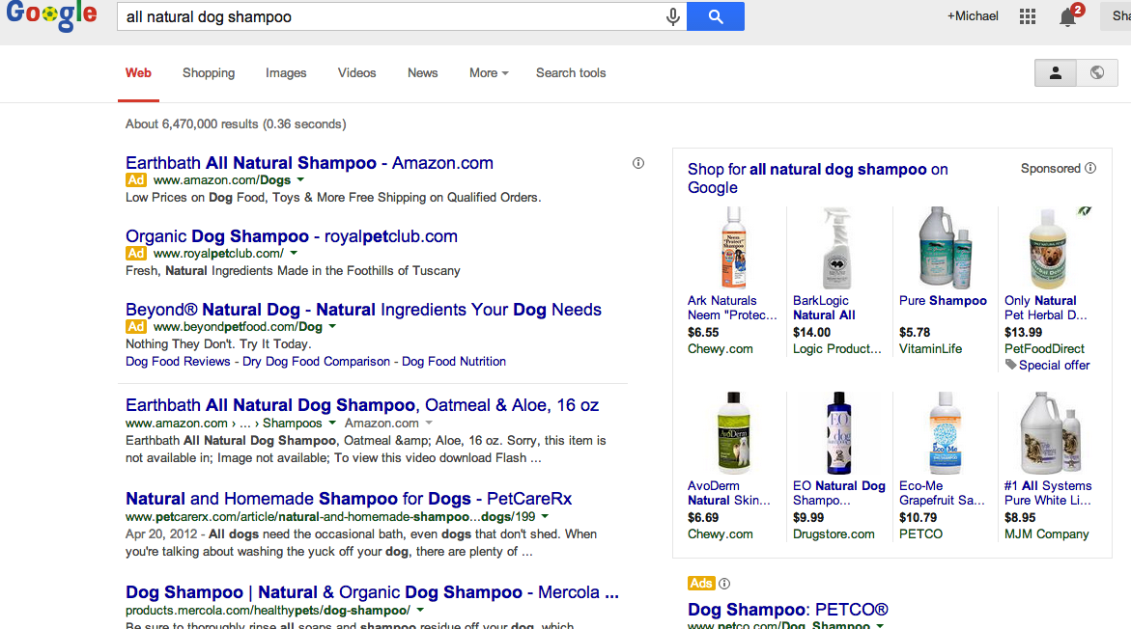

**Task #6**

Run this same competitive analysis test on all ten of your targeted keywords. See if you can narrow down the list even more. Try to **narrow your list down to the five most relevant**, highly searched, least competitive and most accurately competitive terms. **Paste your terms in the space below**.

1. Brightening antioxidant rich cleanser
2. Organic brightening cleanser for hydrated silky and luminous skin
3. Organic purifying brightening cleanser
4. Cruelty free vegan organic brightening cleanser
5. Indie Lee brightening cleanser

Page Optimization

Selecting the best possible terms for your product or service is just half the battle. Once we have terms we would like to target, we now need to add those terms to our web content. After all, if we want people to find our product page by searching “all natural dog shampoo” we better make sure that the words “all natural dog shampoo” actually exists on our webpage!

There are many, many factors that affect how “optimized” a page is for any particular term. [This article written by SEO Moz](http://moz.com/beginners-guide-to-seo/basics-of-search-engine-friendly-design-and-development) does a good job explaining the basics of what search engines like, and what they don’t like. Read through it to get a better understanding of what it takes to optimize a page.

**Task #7**

After you have read through this article take some time to explain what changes you would make to your product or service’s website. These changes should be based on the keyword research you did earlier and the information found in the Moz article and what we have learned in class. In a list of bullet points **tell me what you would changes you will make to your website and why**. I expect you to cite **at least 6 page optimizations** in your answer.

* Key Word stuffing: I need to avoid key word stuffing. Rather than worrying about key words being on the page X amount times I need to worry about phrases reading naturally in a way that’s understandable to the viewers. I realize I included the keywords “organic brightening cleanser” way too often.
* H1 Tag: I need to change my H1 tag because it is important for the H1 tag to be strong and very specific since it represents your page. I’m going to change it to “organic brightening cleanser” rather than just “brightening cleanser.” This makes it more specific to the product.
* Alt text: I am going to change the alt text descriptions. This is because the alt text within images is used to describe images to the visually impaired. It needs to read naturally and avoid key word stuffing. Right now I have no alt text descriptions which isn’t good.
* Formatting for readability: I’m going to add bold type to my page for emphasis. This helps call out important points you want to communicate.
* Title tag: The title tag is one of the most important parts of a page. It plays a huge role in people’s first impressions of a website. I think that I am on the right track but I think it would be best to make it a little more specific.
* Meta descriptions: The meta descriptions are elements that describe the contents of the page that they’re on. These are important because they impact how your site appears in the SERPs and also how many people will be likely to click through your website. Right now I have no meta descriptions so it is very important that I add that.

**Task #8**

Now that you have a plan, go in and make the changes you have outlined above to your website. Please be sure to **place a comment in your HTML code where you have made a change.** Once complete, please [compress the entire website folder structure to a .zip file](https://video.syr.edu/media/t/1_y72oeijl) and submit to blackboard along with this completed assignment document.

**Link Building**

**Task #9**

Another important tactic in a solid SEO strategy is link building. Gaining links from reputable sources with high domain and page authorities is a difficult task. Take a minute to think through where you might focus your link building efforts for this particular product. What sites, blogs or directories might you reach out to? What link building tactics would you use and why? Please write a few paragraphs in the space below explaining your strategy.

For this particular product, I would focus link building towards reputable magazine sources such as Cosmopolitan and Harper’s Bazaar. This is because these magazines have a large following and would attract users and customers. Both magazines have a beauty section filled with articles for promoting products including skin care. For example, Harper’s Bazaar recently published an article titled “The 10 Natural and Organic Face Washes That Actually Work.” If these well known magazines feature the Indie Lee Brightening Cleanser then it is most likely going to build brand awareness for the Indie Lee brightening cleanser.

Additionally, it would be beneficial to be featured in Poosh. Poosh is a lifestyle website that publishes articles, product recommendations, recipes, and advice on everything from wellness, fashion, and fitness. Although Poosh doesn’t have as large of a following as Cosmopolitan and Harper’s Bazaar it would still be beneficial for the Indie Lee brightening cleanser. This is because Poosh is very active on their social channels and has a large following of 4.7 million. Additionally, Kourtney Kardashian, a large public figure, is the creator of Poosh. Kourtney with 199 million followers, her family, and her friends often repost Poosh’s content.

It would also be beneficial for smaller known blogs to feature and promote this cleanser. Utilizing outreach would help build brand awareness and attract more consumers to my website.